6TiSCH and TSCH for Contiki: Analysing energy consumption, joining process and range capabilities

Gianluca Puleri∗†, Simone Monti∗†  
*∗University of Antwerp, Belgium †University of Milano – Bicocca, Italy*  
*Email: Gianluca.Puleri@student.uantwerpen.be, Simone.Monti@student.uantwerpen.be  
Git repository:* <https://github.com/GPuleri/contiki-ng/tree/develop/assignment1>

*Abstract*— Synchronized communication is emerging as a prime option for critical applications. The IETF Working Group 6TiSCH is currently standardizing the mechanisms to use TSCH in low-power IPv6 scenarios. 6TiSCH proposes a protocol stack rooted in the Time Slotted Channel Hopping (TSCH) mode of the IEEE802.15.4-2015 standard. TSCH is one of the key elements of the 6TiSCH stack as part of the IEEE802.15.4e standard and it supports multi-hop topologies with the IPv6 Routing Protocol for Low-Power and Lossy Networks (RPL) routing protocol and is IPv6 through 6LoWPAN [1].

In this paper we will deal with 3 different analyses: we will analyze the differences between IPv6 over the TSCH mode of IEEE 802.15.4e (6TiSCH) and Time-Slotted Channel Hopping (TSCH) Medium Access Control (MAC) layer that is at the basis of 6TiSCH in terms of energy consumption. We will also investigate the joining process of a node to a TSCH network, in terms of time it takes to join the network and the energy consumed by the joining node. Lastly, we will research the range capabilities in terms of latency, throughput and energy consumption.

# Introduction

Nowadays, wireless sensor network (WSN) is one of the emerging technologies, which finds application in a variety of fields such as environmental and health monitoring, military technologies etc. Developers and engineers frequently need to simulate WSN to ensure developed applications work successfully and to analyze effects of various configurations of wireless nodes [2]. To advance the WSNs innovation, a lot of research is conducted to energy efficient and reliability network protocols. Synchronized network flooding with mesh networks based on TSCH, have demonstrated end-to-end reliability upwards of 99.99 %, in real deployments [1].

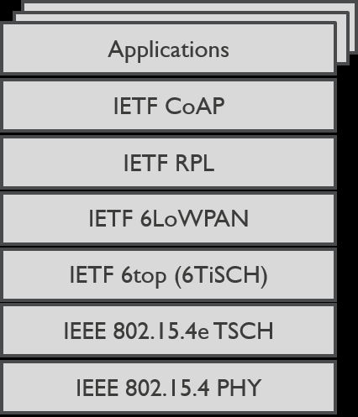

Figure 1. Entire 6TiSCH protocol stack

The industry has been pushing for standardized solutions with the IETF’s low-power IPv6 stack: 6LoWPAN, RPL, CoAP, etc. [3] [Figure 1]. The IETF Working Group 6TiSCH is currently standardizing the mechanisms to run IPv6 on top of TSCH. TSCH is essentially a MAC layer that offers a globally synchronized network of nodes and is used by Low-Power devices to communicate using a wireless link. It is designed for low-power and lossy networks (LLNs). Each node’s activity is dictated by a time-slotted schedule [Figure 2]. In this schedule, communication uses channel hopping. 6TiSCH defines the sublayer for the management of TSCH nodes and schedules [1].

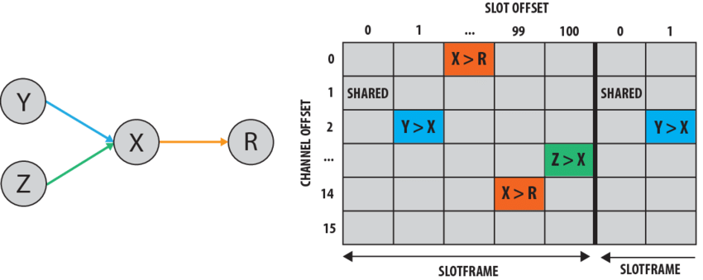

Figure 2. Example of TSCH schedule composed by 100 time slots and 16 channel offsets.

As said before, in this paper we will deal with 3 different analyses:

1. *Analysing the 6TiSCH energy consumption*

For this first analysis, we compare the energy consumption during a certain time period of the entire 6TiSCH stack to when only enabling the TSCH MAC layer, after network convergence. For both analyses, we report on the consumption of the root and the leaf node separately.

1. *Analysing the TSCH joining process*

This analysis investigates the joining process of a node to a TSCH network. We disable the 6TiSCH stack. We report on the time it takes to join the network and the energy consumed by the joining node and the root node. Our report will explain the different parameters that influence this joining process and how. Moreover, we will investigate the EB period and the channel hopping sequence in detail.

1. *Analysing range capabilities*

For the last analysis we will research the range capabilities in terms of latency, throughput and energy consumption of the Zolertia Re-Motes using the TSCH MAC layer. We disable the 6TiSCH stack and set up a TSCH network for the two nodes. We statically allocate one dedicated cell in the TSCH schedule for the leaf node to the root. This cell will be used to send one packet per second: 1 meter, 10 meters, 50 meters and 100 meters. Subsequently, we will repeat this analysis with a smaller and larger TX power value in order to discover how this parameter change the latency and throughput results.

Next, some related works §II are presented. §III introduces the three analyses we focused on. §IV presents our results, followed by a discussion for each analysis. At the end, we provide general conclusions §V.

# RELATED WORKS

This section reviews work related to TSCH, energy consumption and range capabilities. Finally, we compare our analyses to the following works.

*Vilajosana* et al. [5] presents an energy consumption model, obtained by slot-based “step-by-step” modeling and experimental validation on real devices running the OpenWSN protocol stack. This model is applied to different network scenarios to understand the potential effects of several network optimization. The model shows the impact of keep-alive and advertisement loads and discusses network configuration choices.

*Daneels* et al. [6] continue the work made by Vilajosana, but they explore several differences and improvements. As such, they propose a model with an extra time slot type, provide an extended and a more up-to-date set of states per time slot and extend the model to support variable packet sizes.

*Alves* et al. [7] analyze the performance of TSCH leveraging from a real implementation in emulated environment, assessing latency, delivery ratio and time to associate using COOJA simulator.

After reading these papers we propose to continue the work made by them with the analyses of several parameters in the configurations such as EB period and channel hopping sequence during the network association by using a real environment and not an emulated one. Also, we investigate the time to join the network by changing these parameters and we examine range capabilities in terms of latency, throughput and energy consumption in order to better understand how reliable and fast TSCH is.

# EXPERIMENT SET-UP

In the application development phase of the WSNs many interfaces and programs can assist to the developers. One of the appropriate solutions is the usage of Contiki. Contiki is an open-source operating system for resource-constrained devices in the Internet of Things. It has also powerful tools for building complicated wireless communication systems.

Contiki allows you to set the various layers that make up the stack according to your needs. By default, it has the following stack [Figure 3]:

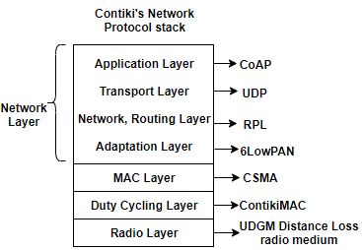

Figure 3. Contiki’s network protocol stack

For the calculation of energy consumption, the use of the Energest module is essential within Contiki. The Energest module provides a lightweight, software-based energy estimation for resource-constrained IoT devices [4]. It was possible to estimate the energy consumption through tracking the time of each active hardware components and multiply it with the power consumption of the component.

For the first analysis, we had to set two different stacks to compare the entire 6TiSCH stack with when we want to have only the MAC layer set to TSCH. For the first one it is therefore necessary to set the MAC layer to TSCH and enable the 6P layer, the one that builds the schedule of the node. For the second one, instead, it is only necessary to set the MAC layer to TSCH without using any routing and network layers.

For the second and the third analyses the stack is also set up with the MAC layer to TSCH and without using any routing and network layers.

Each analysis was performed three times and, subsequently, we used the average of the data to obtain values as real as possible and the standard deviation to measure the variation among the values. Furthermore, an estimate of the energy consumption of the two Zolertia Re-Motes devices was made in Joule following the classic formula:

$$Joule=Ampere x Second x Volt$$

where the values of Volt have been set to 3V and the values of Ampere have been retrieved from the column *Device profiling* present in the following table [Table 1]. We have considered the values of this column because the *CC2538 datasheet’s* column is based on an empirical study and beyond the purpose of this paper.

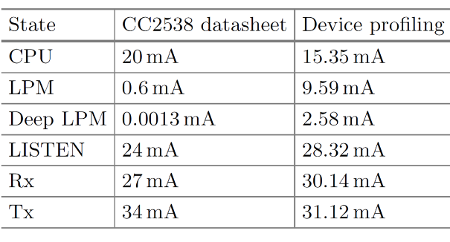

Table 1. Consumption values of Zolertia Re-Motes.

Exclusively for the third analysis, instead, an estimation of the range of capability was made in terms of latency, throughput and energy consumed following the formulas:

$$Latency=arrival at root_{tstamp}-{generation}_{tstamp}$$

$$Throughput=\frac{Received at root}{All generated packets}$$

$$\frac{kbit}{Joule}=\frac{Received \# application bits at root}{Joule}$$

1. *Analysing the 6TiSCH energy consumption*

For the first analysis, three measurements were performed with the entire 6TiSCH stack and three more with only the MAC layer set to TSCH, after the two devices have successfully connected, for one minute each. The average energy consumption is reported, differentiating the root from the leaf node with the same configuration and differentiating the same node when it uses the two different configurations.

1. *Analysing the TSCH joining process*

For the second analysis, we investigated two parameters that play a key role in how fast and efficient the association process is:

* *EB period*: this parameter indicates how frequently a root node send an enhanced beacon (EB) in order to establish a connection among the nodes.
* *Channel hopping sequence*: this parameter indicates how many active channels are used to send or scan an enhanced beacon (EB).

Three measurements were made for one minute for each of the following five sub-analyses:

* WITH DEFAULT SETTINGS

This sub-analysis investigates the time and energy consumption that the two nodes use to connect to the network while maintaining the default Contiki parameters (EB period = 16s, channel hopping sequence= 4).

* EB PERIOD SET TO 2

This sub-analysis investigates the time and energy consumption that the two nodes use to connect to the network by decreasing only the value of EB PERIOD from 16s to 2s.

* EB PERIOD SET TO 8

This sub-analysis investigates the time and energy consumption that the two nodes use to connect to the network by decreasing only the value of EB PERIOD from 16s to 8s.

* CHANNEL HOPPING SEQUENCE SET TO 1

This sub-analysis investigates the time and energy consumption that the two nodes use to connect to the network by decreasing only the value of CHANNEL HOPPING SEQUENCE from 4 to 1.

* CHANNEL HOPPING SEQUENCE SET TO 2

This sub-analysis investigates the time and energy consumption that the two nodes use to connect to the network by decreasing only the value of CHANNEL HOPPING SEQUENCE from 4 to 2.

1. *Analysing range capabilities*

For the third analysis, we were interested in range capabilities at different distances but, during the phase of retrieving data, we noticed that the connection between the nodes over 3-4 meters was not established, so the leaf node could not send packets to the root node.

For this reason, three measurements were performed for 100 seconds for each of the following sub-analyses but only for 1 meter of distance:

* DEFAULT TX VALUE

In this sub-analysis we maintain the default Contiki parameter of the transmission value (TX value = 3dBm).

* TX VALUE DECREASED

In this sub-analysis we decrease the transmission value (TX value = 0dBm).

* TX VALUE INCREASED

In this sub-analysis we increase the transmission value (TX value = 7dBm).

# RESULTS AND DISCUSSION

Here we present our results after retrieving data. We chose to present the results with different kinds of plots in base of the requests. For each plot it is represented the average value with its own standard deviation, even if in some case the three measurements produce the same values and, for this reason, the standard deviation is equal to zero.

1. *Analysing the 6TiSCH energy consumption*

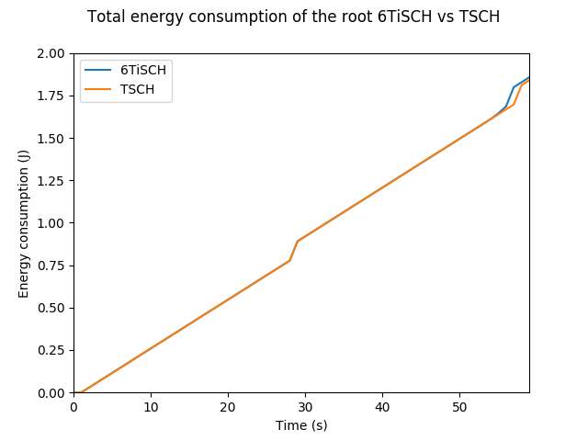

Figure 4. Aggregated energy consumption of the root 6TiSCH vs TSCH

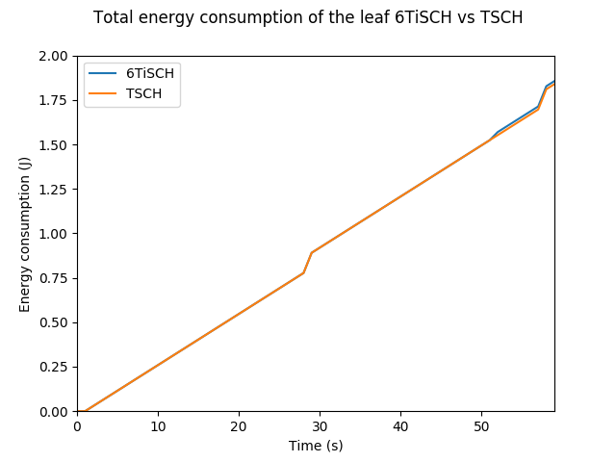

Figure 5. Aggregated energy consumption of the leaf 6TiSCH vs TSCH

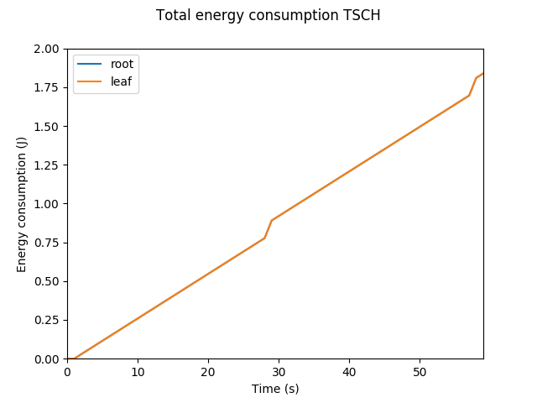

Figure 6. Aggregated energy consumption TSCH

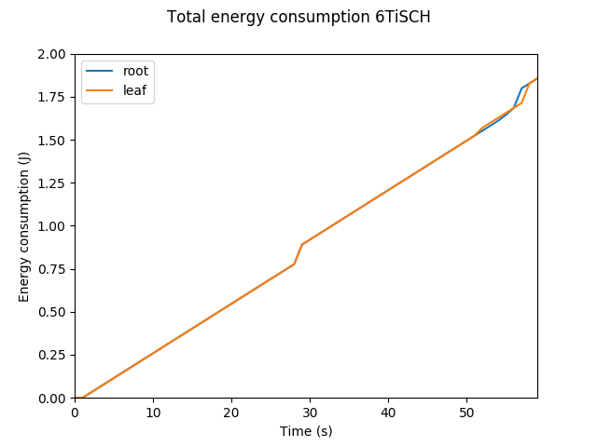

Figure 7. Aggregated energy consumption 6TiSCH

As expected, after the analysis you can note from the graphs above [Figure 4] [Figure 5] that there is not a substantial difference between the entire 6TiSCH stack compared to when only the TSCH MAC layer is enabled. Moreover, it is possible to see [Figure 6] [Figure 7] that the energy consumption of the root node is practically the same of the leaf node. This, because we analyzed the energy consumption only after the network convergence, while to use two different stacks can influence only the energy consumption before the convergence. The same motivation can be used to the root and the leaf node since they do not do anything after the connection has been established.

1. *Analysing the TSCH joining process*

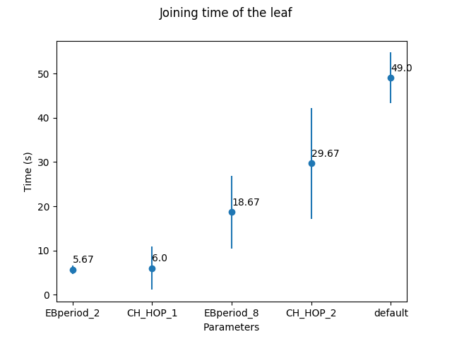

Figure 8. Joining time of the leaf

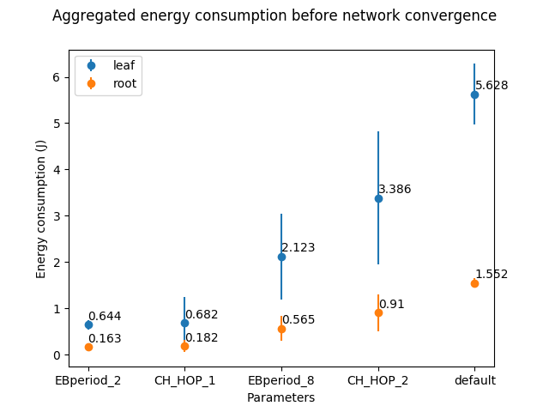

Figure 9. Aggregated energy consumption before network convergence

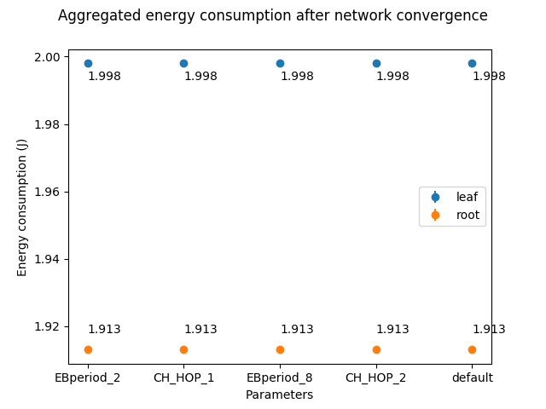

Figure 10. Aggregated energy consumption after network convergence

You can see [Figure 8] [Figure 9] how the EB period and channel hopping sequence parameters have a marked effect on energy consumption and on the time required to establish the connection. It is possible to observe how the EB period parameter, which indicates how often the root node sends an EB packet in broadcast, when it is set to 16 seconds by default causes the joining node to take a long time to connect to the TSCH network. Precisely for this reason, by setting this parameter to a lower value it is possible to notice how the joining node can more quickly connect to the TSCH network.

Similarly, the channel hopping sequence parameter, which allows you to select the frequencies of the channels that will be used for packet transmission/reception, when it is set to 4 by default, causes the joining node to take a long time to connect to the TSCH network. Therefore, to speed up the connection to the TSCH network it is advisable to decrease the number of channel frequencies.

It is also possible to see how changing these parameters the energy consumption changes. In particular, the energy consumed before the network convergence is almost ten times lower when the EB period parameter is set to 2 in compare to default configuration. This happens because the more time it takes to establish a connection, the more energy is consumed. Moreover, the leaf node consumes four times more than the root one because when a root creates a TSCH network it turns off and it consumes energy only when a packet is sent, while the leaf is always turned on to listen to incoming packets.

This difference of energy consumption after the network convergence no longer exists and converge to a constant value [Figure 10]. The reason is attributable to the fact that we were analyze the energy consumption only after the network convergence, when EB period and channel hopping sequence are parameters that influence the connection only before the convergence. From the plot you can see that there it remains a microscopic difference between roots and leaves, but it is present because of the way data were retrieved.

1. *Analyzing range capabilities*

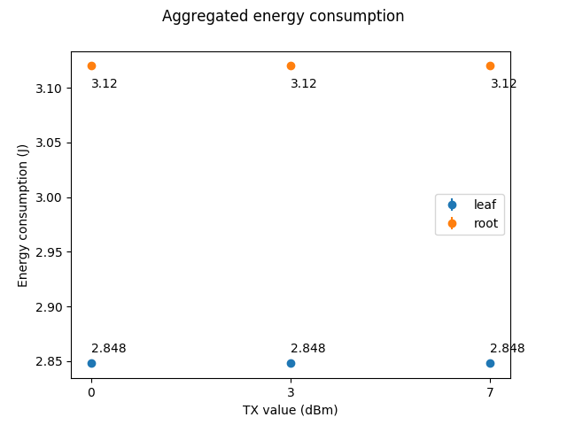

Figure 11. Aggregated energy consumption of root and leaf

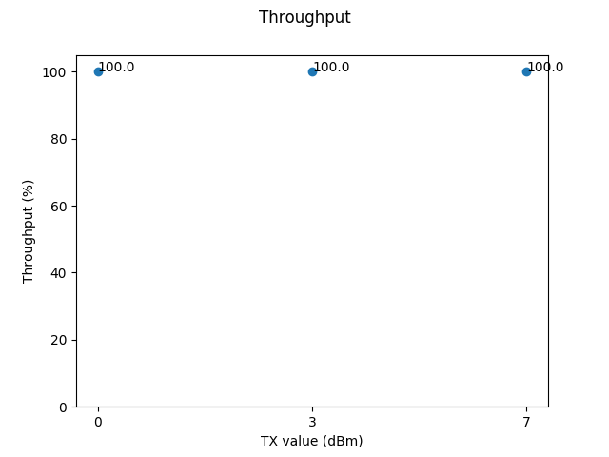

Figure 12. Throughput of packets from leaf to root

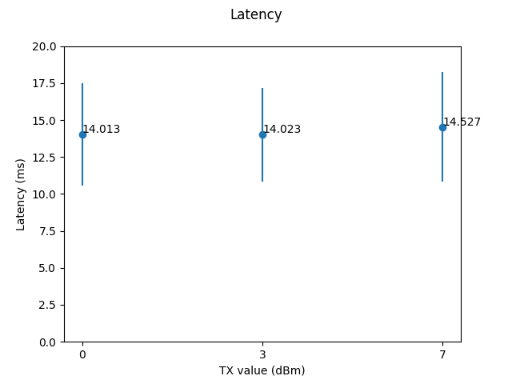

Figure 13. Latency of packets from leaf to root

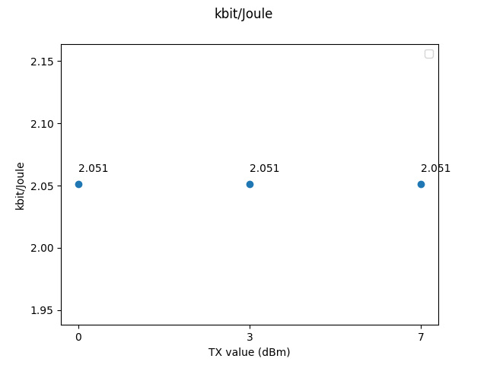

Figure 14. Received number of bits from leaf to root over aggregated energy consumption

You can see [Figure 11] how the root node (the one that receives packets) consumes more energy than the leaf one. The reason is attributable to the fact that the root node is always turned on to listen to incoming packets, while the leaf one turns on only when it has to send a packet. Subsequently, it is possible to notice [Figure 12] [Figure 13] [Figure 14] how all the packets sent have arrived (throughput 100%), the latency is extremely low and the number of received bits over the aggregated energy consumption is constant. It is also possible to note from the plots above that the TX value doesn’t change the energy consumption, the throughput and the latency.

# CONCLUSION

In this paper we discussed about the energy consumption of a 6TiSCH and a TSCH network, the joining time and range capabilities of a TSCH network. In conclusion it is possible to affirm that TSCH provides energy efficiency.

Based on the obtained plots, it is possible to note that there is a difference in terms of energy consumption only before the network convergence, the joining time is strictly dependent on values of EB period and channel hopping sequence, latency and throughput are extremely good at the expense of the short distance to which the nodes can communicate.

##### References

1. Simon Duquennoy, Atis Elsts, Al Nahas, George Oikonomou. TSCH and 6TiSCH for Contiki: Challenges, Design and Evaluation. DCOSS 2017

[2] Xavier Vilajosana, Thomas Watteyne, Tengfei Chang, and Mališa Vučinić, IETF 6TiSCH: A Tutorial, 2019

[3] Erhan Sesli, and Gökçe Hacıoğlu, Contiki OS Usage in Wireless Sensor Networks (WSNs), 2017

[4] http://github.com/contiki-ng/contiki-ng/wiki/Documentation:-Energest

[5] Xavier Vilajosana, A Realistic Energy Consumption Model for TSCH Networks, 2014

[6] Glenn Daneels, Esteban Municio, Bruno Van de Velde, Glenn Ergeerts, Maarten Weyn, Steven Latré and Jeroen Famaey, Accurate Energy Consumption Modeling of IEEE 802.15.4e TSCH Using Dual-Band OpenMote Hardware, 2018

[7] Renan C. A. Alves and Cintia B. Margi, IEEE 802.15.4e TSCH Mode Performance Analysis, 2016